# MIS 6360 Group Project Part 2

This assignment is a group take home project. You should work with the members of your group to answer the questions provided. Collaboration with others outside of your group is not allowed and you are only allowed to work with the members of your group. The assignment is open book and open notes. You may use any resource at your disposal except for directly soliciting advice or input from someone not in your group. Please make sure all sources are cited. Do NOT give or share this assignment with others.

Please answer all of the questions listed below and submit your answers via eLearning. You should answer the questions directly in this document. Please note you should also submit the MS Project File you create and use to answer the questions. Answers will be graded for (1) accuracy and (2) level of adherence to effective business writing standards. Please make sure you answer all parts of each question. ***Please submit BOTH the Word document and your MS Project file.***

The following information is used to answer questions 1 and 2.

# Project Description

The new software-controlled conveyor belt is an exciting project that moves and positions items on a conveyor belt with a high degree of accuracy (< 1 millimeter of error). The proposed project will produce a new system capable of automating the movement of a wide variety of warehouse materials commonly used in order fulfillment. The following information has been developed for you to use in completing the exercises.

# Assumptions and Notes Continued from Part 1

A seven-day workweek is used for the whole year. No holidays.

The project should start on January 1 of the next year.

Resources have identical capabilities and may be substituted for each other. For example, an activity requiring a design resource may be performed by any of the design resources working on the project.

***Warning: Save your work frequently and make backup files as you answer each part.***

***Warning: MS Project leveling options are NOT saved within the project file. Make sure your leveling options are set in Project correctly prior to opening the assignment start file.***

# Question 1 (40 points)

**This question is a continuation of the software-controlled conveyor belt project begun in part 1. Use the included project file to answer the following questions.**

After showing your resource-constrained network to top management, they are very disappointed. After some explanation and negotiation, they make the following compromise with you:

* The project must be completed in no more than 285 days**.**
* **You may NOT make any changes to tasks 1, 2, 3, or 4.**
* One additional Design resource has already been added to the project.
* If you think it is beneficial, you may assign one additional development resources at the same cost rate as the original development resources.
* If this does not suffice, you may hire other people from the outside. Hire as few additional external people as possible because they cost $75 more per hour than your inside people.
* The scope of the project remains the same and the amount of work for each task may not be changed.
* Task dependencies may NOT be changed.
* Overtime is allowed, but the cost rate is 1.5 times the standard cost rate
* If overtime is used, total working hours may not exceed 16 hours per day
* Splitting of tasks is allowed
* Resources assignments less than 100% are allowed
* ***Activity durations are not fixed meaning adding additional resources to an activity decreases the duration of the activity.***
* ***Your changes should minimize the impact to the overall project cost.***

1. Include a screenshot of your final Gantt chart clearly identifying the critical path. What is the new finish time in number of days? What is the new finish date?

Finish time : 280.15 days

New finish date: 10/8/2025

b. Paste a screenshot of your resource sheet below and describe all of the changes you made to the resources assigned to your project.

Added a new resource to Development at same rate (as mentioned in the question)

Added 2 “External Test” resource with the rate as $140 ($65 +$75)

Added 4 “External Development” resource with the rate as $190 ($115 + $75).

c. List the changes you made to each task in the project to meet the new project deadline. For each task, clearly describe all changes, if any.

|  |  |
| --- | --- |
| **Description** | **What change(s) did you make to the task?** |
| System architecture | No changes |
| Hardware specifications | No changes |
| Kernel specifications | No changes |
| Utilities Specification | No changes |
| Hardware Design | Added extra resources for Design and Development and also overtime of 280 hours for both. |
| Disk drivers | Added 1 external Test and 2 External Development resources. Reduced “Development” resource by 50%. |
| Memory management | Added 4 “External Development” resources. Both type of resources had 112.5h of overtime. |
| Operating system documentation | No changes |
| Routine utilities | Added extra “Development” resource. |
| Complex utilities | No changes |
| Utilities documentation | No changes. |
| Hardware documentation | No changes |
| Integration first phase | 2 Development Resource and 1 “External Test” added. |
| Prototypes | 1 External Development and 1 External Test resource added. |
| Serial I/O drivers | 2 Development resource added. |
| System hard/software test | 1 “External Test” resource added. 40h overtime for both types of resource. |
| Order printed circuit boards | No changes. |
| Network interface | Reduced Development to 50% |
| Shell | Reduced Development to 50% |
| Project documentation | No changes. |
| Assemble preproduction | Added “External Test” resource. |
| Integrated acceptance test | Added 1 extra “Development” and 1 “External Test” resource. Also 74 hour overtime for “Assembly/Test”, 57h overtime for “Development” and 28.5 hr overtime for “External Test” |

d. What is the total cost of the project?

The total cost of the project is **$1,402,192.08**

e. Include a graph of the total financial schedule over the life of the project by month. This is the planned value for the project. The graph should depict time on the x-axis and dollars on the y-axis over the life of the project.

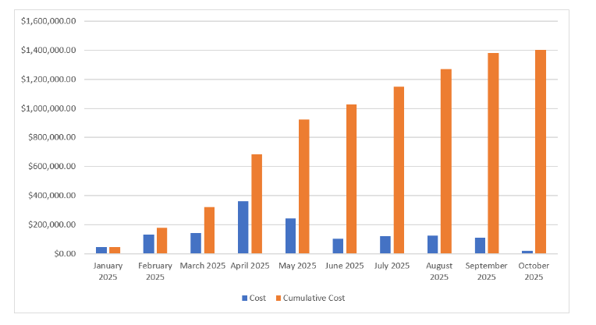

f. Include a screenshot of the total costs for each activity/work package.

Remember, your financial schedule should follow your resource schedule, not the original network. Because the project has not started yet, all of your variances, schedule, cost, earned value, and actual cost should be zero. Once you are confident that you have the final schedule, save the file as a baseline. (Hint: Save a backup file just in case without baseline!)

# Question 2 (40 points)

Prepare a status report using the information provided below. This requires saving your resource schedule as a baseline and inserting the appropriate status report date in MS Project. The MS Project tutorial on eLearning and the discussion forum pertaining to Earned Value Management may be of use in answering this question.

Status Report Date: February 28, 2025

|  |  |  |  |
| --- | --- | --- | --- |
| **Activity** | **Description** | **Actual Duration** | **Remaining Duration** |
| 1 | System Architecture | 40 | 0 |
| 2 | Hardware specifications | 19 | 45 |
| 3 | Kernel specifications | 19 | 0 |
| 4 | Utilities Specification | 19 | 0 |

a. Include a screenshot of the status in table form that shows the PV, EV, AC, BAC, EAC, SV, CV, SPI, and CPI for (1) each work package and (2) the whole project using the status date listed above the table.

b. Based on the performance of the project team, what are the Estimated Cost at Completion (ECAC) and the Estimated Time at Completion (ETAC) for the project as a whole?

The Estimated Cost at Completion (ECAC) is **$1,357,296.09**

The estimated time at completion after the status date is **243.65 days** i.e. September 1st 2025.

c. How is the project as a whole progressing in terms of cost and schedule? Be specific in your response and clearly identify the amount, if any, the project is over/under budget and the schedule change, if any, the project is ahead/behind schedule in number of days.

|  |  |  |  |
| --- | --- | --- | --- |
| **Project Name** | **Original Project Duration** | **Estimated Time at Completion (ETAC)** | **Schedule Difference** |
| SCCB |  |  |  |

|  |  |  |  |
| --- | --- | --- | --- |
| **Project Name** | **Original Project Cost** | **Estimated Cost at Completion (ECAC)** | **Cost Difference** |
| SCCB |  |  |  |

d. Complete the following table describing the performance of each task in the project so far. For each task, compare the original planned schedule and cost with the actual schedule and cost as of February 28. For tasks that are in progress, please also include the estimated scheduled finish data and the estimated cost at completion and compare these estimates with the original plan.

|  |  |  |  |  |
| --- | --- | --- | --- | --- |
| **Activity** | **Description** | **Original Planned Duration** | **Actual/Estimated Duration at Completion** | **Schedule Difference (Days)** |
| 1 | Architectural Decisions |  |  |  |
| 2 | Hardware specifications |  |  |  |
| 3 | Kernel specifications |  |  |  |
| 4 | Utilities Specification |  |  |  |

|  |  |  |  |  |
| --- | --- | --- | --- | --- |
| **Activity** | **Description** | **Original Planned Cost** | **Actual/Estimated Cost at Completion** | **Cost Difference (Dollars)** |
| 1 | Architectural Decisions |  |  |  |
| 2 | Hardware specifications |  |  |  |
| 3 | Kernel specifications |  |  |  |
| 4 | Utilities Specification |  |  |  |

e. Which activities performed as planned? Which activities did not go as planned?

f. What changes will you make moving forward to try and bring the project back on track? Be specific in your response clearly identifying the tasks and/or resource changes you plan to make.

g. Include a Gantt chart of your revised project after making the changes listed in part f.

# Team Member Contributions (0 to -100)

List and briefly describe the contribution of each team member on this assignment. The description should be one or two sentences at most.